Granular Sugar

:

An experimental Granular Sampler Instrument

by

Adam Kay
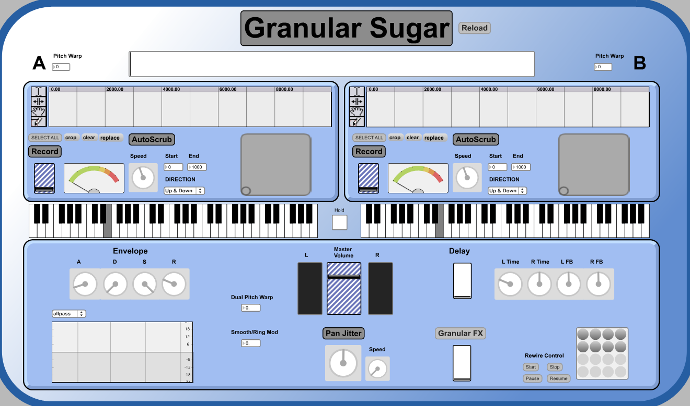

Contents

Introduction

Finished Product write up:

- Design process
- GUI
- Evaluation

Quick start user guide

External Device guide

- Music Controller
- Nintendo Wiimote
- Korg Kaoss Pad (KP3)

Appendix 1 – Original Proposal

Appendix 2 – Prototype

Bibliography/ Research

Introduction

Over the last few years I have enjoyed experimenting with granular synthesis on programs such as Absynth and Reaktor. I was made aware of granular concepts and sounds through artists such as Autechre, Aphex Twin, Venetian Snares and Apparat (http://www.youtube.com/watch?v=PVdKacGcRQs). After experimenting with granular synthesis mostly in Reaktor, I began creating sounds to use in my own music. A feature that I particularly enjoy is being able to sculpt sound using unconventional controls such as grain position, length, density, smooth and speed and then re-pitching the sound across a midi keyboard. For me this opened up an exciting new range of sound possibilities and textures as I find the process of sculpting these sounds by ear very appealing and different compared to creating sounds on a subtractive synthesiser for example.

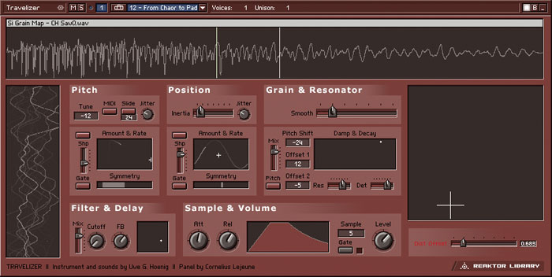
There are many things that I like about the Reaktor instrument ‘Traveliser’ and ‘Grainstates’ but there are functions of both that I am not particularly interested in using, and that while one has the ability to do one thing, the other does not. I realised that while these programs have the ability to create many semi-random unpredictable sounds and textures, it took a lot of careful tweaking to produce the controlled musical sounds that I prefer. Also I didn’t feel that they were very useable in a live/performance situation. For these reasons I have decided to use granular synthesis as a starting point for my system.

After research, I am still not aware of any programs that are dedicated to creating the sounds that I have in mind which is why I am interested in the idea of making a system that is quite unique and personal to me, that I will want to use myself in music sound creation and performance.

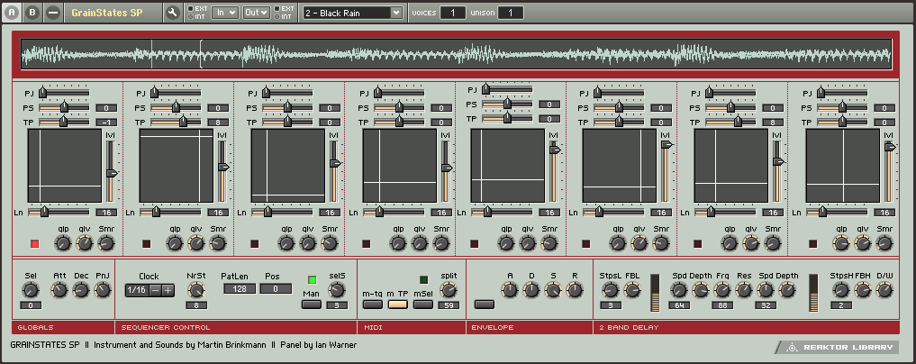
The following pages go into detail about the specifics of the design as well as many of the system processes which take place. Following that is a 'Quick-start/User guide manual' for 'Granular Sugar' as well as instructions for using all external software and devices; Music Controller, Wiimote and Kaoss Pad. My original proposal design is included for reference in Appendix 1 and my prototype system is analysed in Appendix 2.

Finished Product Write Up

Welcome to 'GranularSugar', an experimental granular sampler instrument.
GranularSugar samples and manipulates audio using granular and traditional effects. There are two sample banks, both in to which you can either load an audio file from disk, or record live.

Specifications

- 2 sample banks for audio files or live sampling
- Re-pitch and re-trigger samples using a midi controller/keyboard, on-screen keyboard or computer keys
- Channel Crossfader
- XY Pads control grain length and position
- Auto-scrub
- ADSR Envelope
- Granular Effects
- Stereo Delay
- Adjustable Filter with 6 presets
- Pan Jitter
- Smoother/Ring Mod
- Dual Pitch Warp
- Store and load presets
- Rewire control
- Nintendo Wiimote and Korg Kaoss Pad compatible

Design Process

Pan Jitter
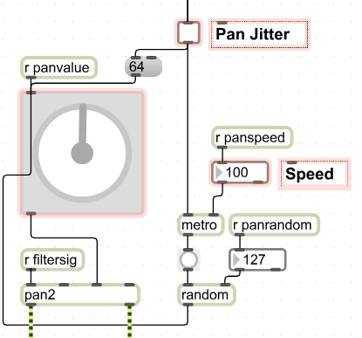
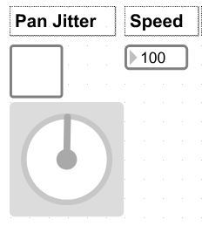
The Pan Jitter effect sends the overall signal to a random point in the stereo field. You can adjust the speed at which it jitters by adjusting the Speed number box. The key objects used are 'metro', 'random' and 'pan2'. Once the Pan Jitter toggle has been activated the metro is turned on and sends out a continuous stream of bangs with a time interval (speed) set by the number box in its right inlet.
Every time the random object receives a bang in the left inlet, it outputs a random number between the range set by the right inlet number box. I have set this number to stay at 127 (full range) and is not accessible by the GUI. This means that the effect is at its most extreme all the time. I could consider changing this in the future to give more control over the amount of randomness used. The random number (between 0-127) is then sent to the dial object to give a visual representation of what the pan jitter is doing, before being sent to the third inlet on the pan2 object because it accepts numbers between 0-127. The pan2 object then sends out its left and right outlets appropriately.
Note the use of the message box containing the number 64 which is also connected to the dial. 64 is halfway between 0-127, so is in the middle of the stereo field. The 64 message receives a bang every time the toggle is clicked so that the panning will always automatically move back to the middle once Pan Jitter is deactivated. Of course when Pan Jitter is deactivated, the pan dial can be used as a standard master pan.
I have also since added a dial and scale object to the Pan Jitter so that you have smooth control over the speed.

Grain controls

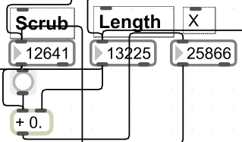
The 'Scrub' and 'Length' controls are two of the most key parts of my system as they are what make some of the more advanced processes such as auto-scrub possible. The 'Scrub' number box is connected directly to the waveform~ objects 'Selection Start' inlet. This moves the start position of the waveform display selection. The inlet to the right of the selection start inlet is the 'Selection End' inlet. I originally used this and the start inlet to specify the length and position of the selection but to achieve the scrub effect I wanted I had to include a few more processes.
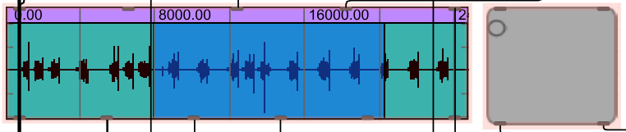
The 'Scrub' control is also connected to a + (plus) object. Plus stores, adds and outputs the total when it receives a bang. The 'Length' control is the other number that is connected to the + object. The output of the + object is connected directly to the number box marked 'X'. By adding the Start and End points you get the total length (X) which is connected directly to the 'Selection End' inlet.
In practice this means that rather than simply adjusting the start and end points, you can adjust the position of the whole selection in one process, as well as the length. Of course these controls are not viewable in the GUI because I have used an XY pad instead, but these are the controls that make a lot of the following processes possible.

XY Pad and Scale

The XY pad is used in the GUI as a great way of moving and manipulating your selection. This is far more visually appealing and also highly practical because it lets you change two parameters with one mouse movement. The XY pad simply makes use of the Scrub and Length controls already mentioned above. The vertical axis is connected to the Length and horizontal axis to the Scrub. However connecting them directly did not work so well because the numbers coming out of the XY (pictslider object) were not useful because of the huge variation in numbers dealt with by the waveform~ object, length and scrub controls.
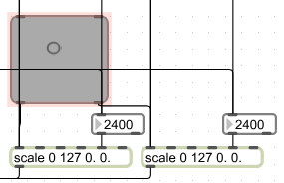
This was quite a problem for me to begin with. Changing the maximum values of the XY pad in the inspector made it slightly more useable in more situations but the audio file would still often be out of range and to increase the numbers any further meant that the movement to get from one side of the pad to the other was huge.

Using a scale object I was able to increase the range by giving it the argument [scale 0 127 10000. 10000.] This eliminated the problem of movement across the pad but was still very limiting because I wanted the pads to work for audio files of any length, and for their behaviour to be adjusted accordingly.
I eventually solved this as shown above; I used two scale objects (one for X, one for Y) and connected number boxes to the 'High output value' inlet. This allows you to update and adjust the scale. This number box is connected directly to the waveform~ 'display length' outlet which gives this number every time the display length is adjusted. This was extremely useful because the Wiimote and KP3 also make use of this.

Auto-scrub

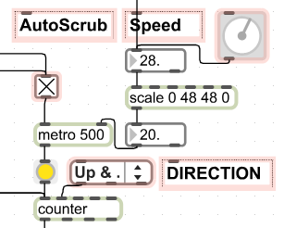
After the grain controls were working I got the idea for an auto-scrub feature to make further use of the grain controls. This allows you to automatically scrub through the grain cloud by adding speed and direction settings to the already mentioned start, end and length controls.
Activating the Auto-scrub toggle turns on the metro object which bangs the counter. The speed of the metro is set in the right inlet. I have used a dial object with its range limited to 48 in the inspector because I found this gave the smoothest speed (the prototype version was behaving erratically at higher numbers). I used a scale object to invert the numbers coming out so that the dial works as minimum to the left, maximum to the right.

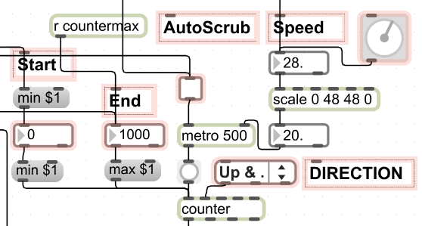
By attaching number boxes to 'min $1' and 'max $1' messages we can set the minimum and maximum values of the counter object. This controls what position in the waveform the autoscrub will read.
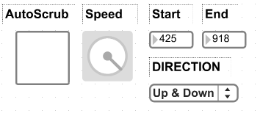
I had many problems with keeping the autoscrub in range but I fixed this by connecting the waveforms 'display start' outlet to the 'auto-scrub start' and the 'display length' to the end number box. This means that every time the audio is cropped, the auto-scrub number boxes are updated with the new display length information.

Mixer
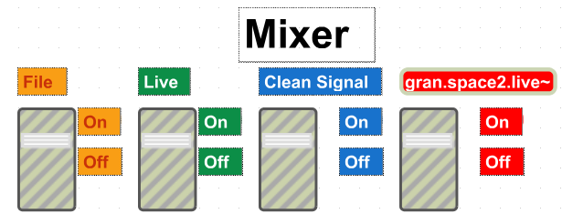
The mixer section in my prototype, as shown above was quite confusing with its 'clean signal' channel and many switches. What was bad about this was that all of the signals were being added to each other meaning that if you brought in the granular effects, it would add a lot of volume to the overall mix often peaking the overall level, then to hear only the effected signal you would have to turn the clean signal down, however you would have to still have signal coming from the file and live. What I needed was a system that eliminated this 'clean signal' channel and balanced out volumes when you added more effects.

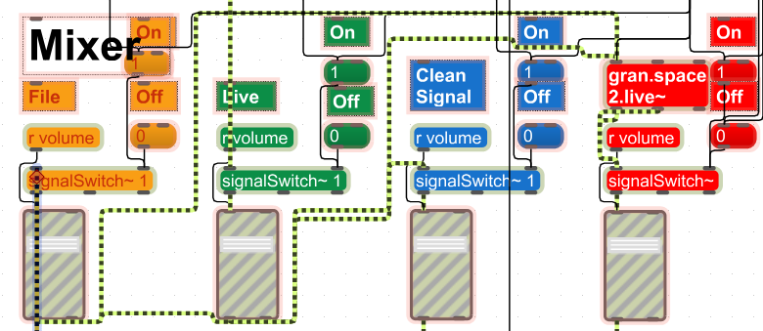
To overcome these problems I used the expression '1- $f1'. What this does is to take the number coming in (in this case from 0-1) and invert the output, so that you are not simply adding more signal, but adding to one while taking away from the other. For the mixer crossfader, this means that we have eliminated the unneeded clean channel and can now mix the two channels together to whatever amount we like in one movement. For the granular effects and delay, it means that you can control the dry and wet signal without adding more volume.
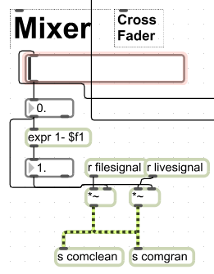
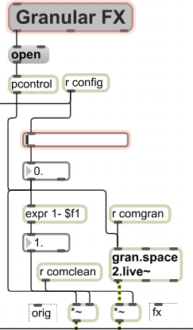
My finished version of what was the mixer, has changed a lot both in the patch and the GUI. Firstly the channels are no longer 'File' and 'Live' but A and B instead because each can take files or live recordings. I realised that on and off switches were not really necessary for my new design and instead you can now you can use a crossfader to easily balance the levels between A and B. In this respect I took influence from DJ style mixers and software such as NI Traktor because of the similarity in GUI. I placed the crossfader horizontally across A and B so that you actually have a clear visual representation of which channel is where in the mix.

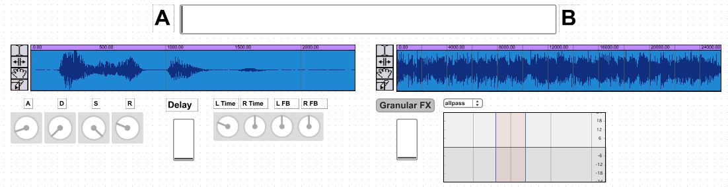
The delay and granular effects work in a very similar way, raising the fader adds more of the effected signal while taking away from the clean signal. Therefore all the way down is completely dry and all the way up is wet.

Delay
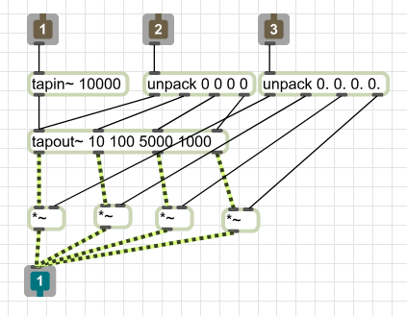
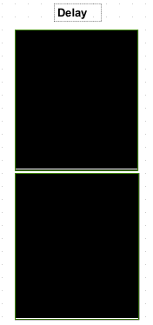
The pictures to the left show the original delay that I made, it uses the tapin~ and tapout~ objects as well as two multisliders. The tapin~ object acts like a live audio buffer in that it stores audio coming into it. You can specify the length that you want tapin~ to remember (tapin~ continously stores signal coming in). The tapout~ object is used to pull the audio from specified time points from the tapin~ object.

The multisliders allow you to control delay time with the top one and volume with the bottom. I thought that this was quite a good idea at the time but in the end found it to be overly complicated and slow to use. The patch itself is very simple, the data from the multisliders is transferred to the tapout~ by the unpack object. The unpack connected to inlet 2 is for the delay time and the one connected to 3 is for the volume.

For the final version I decided to use the delay from the help file with the addition of a dry/wet level (as mentioned in the mixer section above) to mix the delayed sound with the clean/dry sound, and I used some dials for the GUI. This delay is easier for the user to understand and quicker to use which is why I decided to change it.
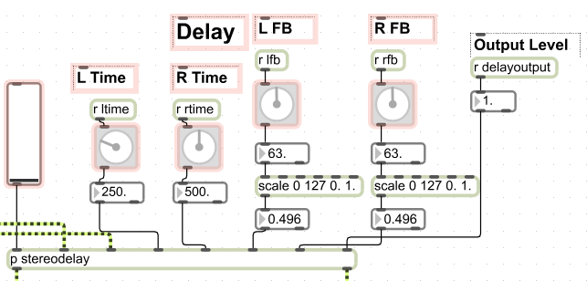
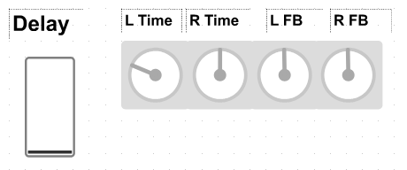
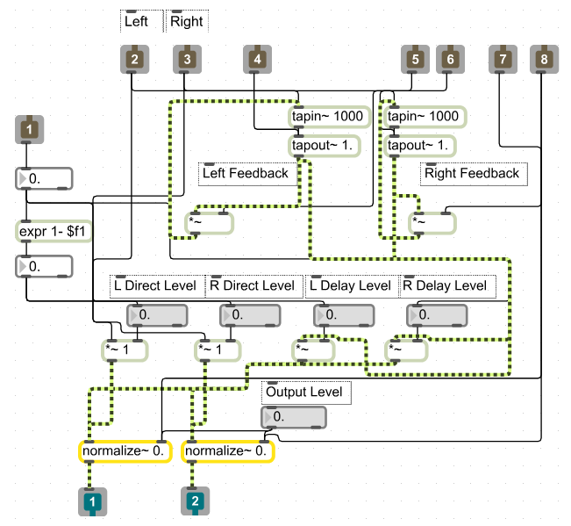

Gran.space2 effects

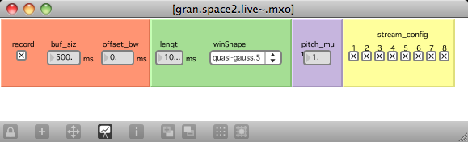
I have used an external made by Nathan Wolek called gran.space2.live. This is part of his popular GranularToolkit for Max/MSP. Gran.space2 records the live audio signal being input using an internal looping buffer while the processing is taking place. The toolkit contains many abstractions and externals which I experimented with before deciding on using this one. I also tried other externals such as mdegranular and graintools which I did not find to be as useful as this one.
This external gives you quick access to some sophisticated granular effects and parameters that include grain offset, length, window shape (of which there are many to choose from), pitch and a stream configuration which I have found to work very well with my pan jitter effect for creating glitchy spacial sounds. These streams are numbered 1 – 8 and can be turned on or off in order to make different spacial effects.
With the user in mind, gran.space2 can be added by simply turning up its level slider as shown below. Clicking on the text button 'Granular FX' will bring up the a new window for the external effect parameters. As 'Granular Sugar' is not yet polyphonic, the pitch multiplier gives you some options to create harmonies (in fact with two channels and the external running together you can get three pitches with one midi note).
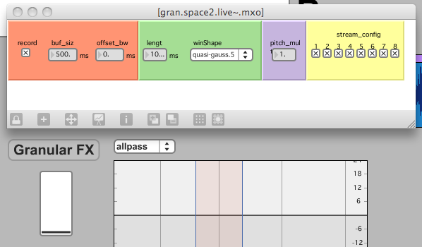
Wiimote
As an extension to my project and to further my systems capability as a live performance tool, I have connected some of its functions to the Nintendo Wiimote controller. This gives the user the ability to wirelessly control many of my systems features in an unusual, fun but practical way.

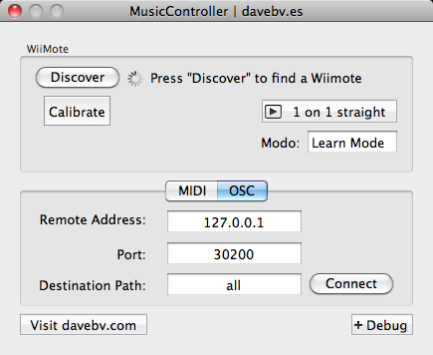
My first version of the Wiimote control, uses one Wiimote (no nunchuk) connected via the program 'Music Controller' (http://www.davebv.com)(http://code.google.com/p/musiccontroller/wiki/OSCWiimote) .
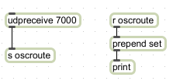
To get the Wiimote working with my patch I used the OSC Route external (http://cnmat.berkeley.edu/patch/4059) with the Music Controller application. When used with the udprecieve object Max can receive the data from Music Controller. I extended the patches from the wiitest patcher to work with my own patch so that the Wiimote responds as follows;

Roll – Position
Tilt – Length
B – Turn on Roll/Tilt
A – Record
1 – Auto-scrub
2 – Pan Jitter
Home – Reload
Minus – Crop
Plus – Select All
Down – Dual Pitch Warp Up
Up – Dual Pitch Warp Down
Left – Move Crossfader
Right – Move Crossfader

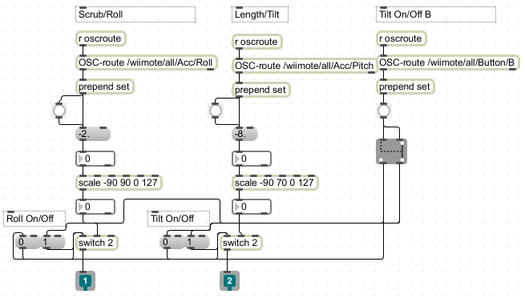
Above is part of my Wiimote patch showing the Scrub/Roll, Length/Tilt and B Button/On and Off controls. I have used the scale object to control the response from the Wiimote in two ways.
Firstly I have simply scaled the numbers coming into the Scrub and Length to 0-127, this is so that it works perfectly with my XY pad.
Secondly I found that when actually using the Wiimote, it was not behaving the way I had expected it, or wanted it to. For the Roll, the Wiimote had almost 360 degree turning which I found was to much as it is a lot of effort to turn your wrist this far. The tilt had a similar problem in that you would have to tilt it down from a flat position towards the floor bending your wrist back when I felt it should have been going from upright to flat. To rectify this, because the oscroute was connected to a print object, I could view the numbers coming out in the Max window. I noted down the numbers that I wanted my range to be and changed them to this. I tweaked these numbers a bit the more I used it and settled on the numbers above. This control makes a lot more sense when using my system and works much better!
Using the tilt and roll functions you can select Position and Length in the same way as with the XY Pad. The B trigger is used to turn off and on the tilt and roll. By holding down the B trigger on the Wiimote you are turning on the switch that controls tilt and roll, this means that when you are happy with the selection you have made, releasing the B trigger will hold position and length where they are. Before I made this switch, it would be constantly receiving new information all the time thus altering your selection. The switch system above is probably not the best or simplest option but I was having problems making it work and had tried a few different ideas, this one worked so I stuck with it. It uses a switch 2 object (connected to roll and tilt) and a gswitch 2 object (connected to B button). One of the gswitch 2 outlets is connected to the off buttons connected to the switch 2, and the other outlet is connected to the on buttons of both switch 2 objects. This means that when you hold down the B button on the Wiimote the On buttons are sent a bang and when it is released the Off buttons are then sent a bang.
Kaoss Pad

The diagram below demonstrates which of the KP3's buttons can potentially be used for receiving midi information and which CC number they are associated with.
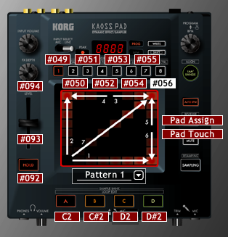
FX Depth – 94
FX Release – 93
Hold – 92
A – C2
B – C#2
C – D2
D – D#2
1 – 8 : 49 - 56
X – 12
Y – 13

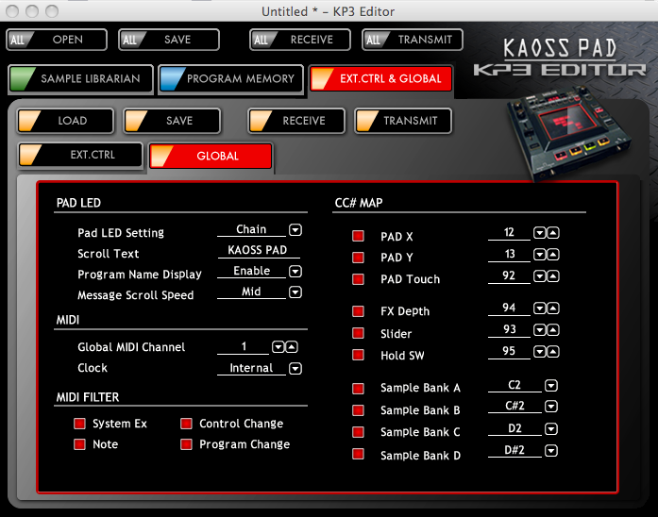
However, so far I have only managed to get information out of FX Depth, FX Release, Hold and X/Y. There are a number of different ways of making the Kaoss Pad function such as using it in USB or EXT. CTRL mode, however I found best results from using it in standard mode. The KP3 editor software can be used to re-assign CC# and other functions which I have not fully understood yet as the KP3 compatibility is an extension to the system rather than a key feature. Having got the XY pad working as well as a fader, dial and button, I feel confident that I will be able to eventually have all of the buttons working to my satisfaction.
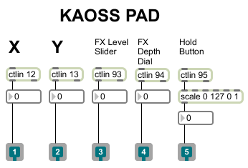
To the right is my Kaoss Pad patch for the working controls. The outlets can simply be connected to any parameter that you want, provided it is receiving the correct number message. The Hold button is an example of a message that had to be changed; my max patch wanted 0 – 1 (off and on) but the Kaoss Pad sent out 0 – 127 so the scale object fixes this.

I saved the Kaoss Pad and Wiimote patch as separate patchers with outlets (shown below) because they will be very useful to me and others, particularly when it is finished because I imagine some people have had the same problems as me. Also this was a good way of tidying up my patch.

GUI

The GUI for my system has changed a lot since the prototype. The prototype version had bold contrasting colours, it also had a lot of buttons and switches, so I have made an effort to minimize this. There is a lot of functions available but using for example the XY pad meant that I could turn two ordinary number boxes into something more appealing and interesting. I have also switched the many labelled On/Off switches for text buttons.
I have used coloured panels to separate the different sections of the GUI. On the left in one panel I have placed all the A specific controls and on the right in another panel I have put all the controls for B. So now it is differentiated not only by being on opposite sides but you also have a box and border to show the separation.
In the large panel below it, I have put all of the global controls (i.e. things that affect both A and B channels) such as the delay and filter effects. Before I did this, I think that the user could possibly have expected for the objects on each side to be channel specific, whereas now it is very much separated.
I made an effort where possible to use text buttons as they look a lot better than the message boxes. When you click them they show this and in the case of On/Off buttons they are grey when off and blue when on fitting the colour theme and also highlighted when mouse is hovering over to show that they are useable buttons.
The waveform is a great GUI tool. Some software such as 'Absynth' doesn't actually show the audio wave at all and I found that this made me feel less connected with the workings of it. The selectable waveform allows you to visually understand what are you hearing and helps you to select the grain; for example seeing a kick beat or piano note as opposed to only using your ears.
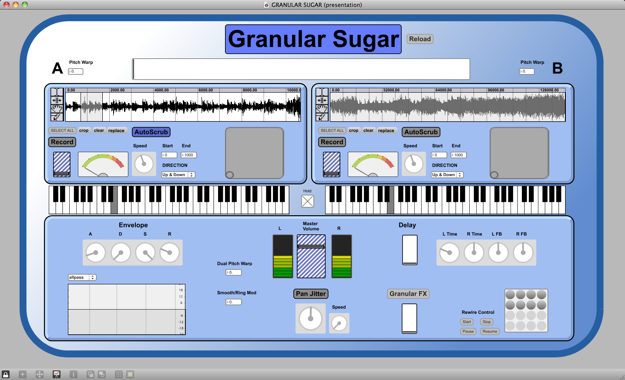

Evaluation

I have far exceeded my initial expectations with my finished system. By the prototype stage I had surpassed all my aims and introduced a lot of new ideas as well that were new to the finished product proposal.
One of the hardest things about creating my system, was getting and keeping a variety of different number ranges and processes to work with each other. It was essential that these processes happened in the correct order and updated each other as soon as changes were made. I have gone to great effort to make sure that all of the processes involved in cropping, scrubbing, auto-scrubbing, file replacing and selecting would all stay in range of each other and update accordingly. This included the use of the XY pads, Wiimote and KP3. I would say that this was one of the most challenging parts of my system but would not be immediately obvious as something that took a lot of work. For example here are some of the problems and processes that I considered and overcame which make a difference to the reliability of my system (particularly to the user who does not have knowledge of these intricacies);

- When you replace a file, making sure that the buffer, waveform display, auto-scrub and XY pads minimum and maximum are all resized automatically. This eliminated the massive problem of losing sound because of the selection becoming out of range.
- Making sure that whenever a file was replaced or cropped, the whole newly resized waveform was selected automatically to avoid being out of range.

These are not the sort of things that you notice as being an important part of the system but without them functioning properly and in the right order, the system would be practically unusable. It involved consideration and a hours of trial and error mostly involving the buffer~, groove~, waveform~ and scale objects in conjunction with number boxes and assorted messages. This was made more difficult by the increase of processes involved. Adding a new element such as the auto-scrub section would create new problems and change the order or processes having to be carried out.

Wiimote
The wiimote works really well with my system, it was not completely straight forward as I had quite a few problems with creating switches, controlling ranges and scaling to get it working the way I wanted it to, but I feel that I have mostly achieved this. The switches are probably not the simplest or best design but they do work which is the important thing. Being able to control a complex system like this wirelessly with one small controller makes it a lot more user friendly and fun and you have a lot more possibilities because you can control many of its functions at the same time unlike using it on screen with a mouse.

Kaoss Pad
Surprisingly to me, the KP3 was much harder to get working than the Wiimote. I had trouble initially getting any information out of it and have not got all of the buttons working yet. When using the KP3 with GranularSugar, it stops receiving information quite regularly and you have to reload Max/MSP to get it working again.
Although I have not got the KP3 functioning nearly as well as the Wiimote, I actually spent a lot longer on getting the KP3 to work. I could find very little information on using a Kaoss Pad in this way, whereas there was plenty of patches, programs, discussions and help with using Wiimotes. For these reasons I am pleased with what I achieved from the KP3 as I worked most of it out for myself and it does not need to use any other programs such as 'Music Contoller' to function. I would like to go on and learn more and possibly create a good working patch and set of instructions for other people to reference.
I have shown that it is possible to get some of the Kaoss Pads dials and buttons working and I will go on to get full compatibility. This demonstrates the capabilities of GranularSugar as a unique live performance tool. I could find very little information regarding using a Kaoss Pad with Max/Msp. From studying the KP3 manual and software editor, I realised that it was not possible to use all of the buttons as I had hoped because they do not all send out midi messages, however I did manage to get information out of the XY Pad, two rotary dials, one fader and one button and I have set all of these to control parameters within GranularSugar.
The KAOSS Pad was an extension to my project so I am pleased to have got it working. It is clear to me that with more time its possible to be able to use more of the Kaoss Pads functions that are available

Furthering my project
I have thoroughly enjoyed designing and making GranularSugar. I wanted to create something that I would use in my own music production and performance and I have done this by using it extensively on my FMP album 'Binauralbeats'. It was used for many of the synthesised sounds as well as for creating soundscapes and atmospheres. I am also now working on using it in a live situation with a band to create spontaneous granular samples and glitchy noise helped by the Wiimote and KP3 compatibility. I will definitely continue to work on GranularSugar, adding and expanding to its capabilities.

GRANULAR SUGAR : QUICK START USER GUIDE

Welcome to Granular Sugar – a highly unique granular sampler instrument

Features

- 2 Sample banks A + B for loading Audio files or Live recording
- XY pads give total control over Grain length and position
- Auto-scrub feature – set Start/End points, Speed and Direction and let auto-scrub take control
- Channel Crossfader
- ADSR Envelope – gives you control over the attack, decay, sustain and release times
- Filter – with 6 adjustable presets
- Delay
- Smooth/Ring Mod – a tremolo/ring modulation effect
- Pan Jitter – control the speed that sound is panned to a random position
- External granular effect 'gran.space2' adds even more extreme granular sounds
- Pitch adjustment for each channel and dual pitch warp for extreme pitch shifting
- Select and store presets
- Midi Controller/Keyboard compatible (alternatively use the on-screen keyboard or computer keys “z to ,”) to re-pitch and re-trigger samples
- Hold function - continues to re-trigger last note played
- Rewire Control – lets you easily route audio into Logic, Ableton and other Rewire compatible software
- Nintendo Wiimote and Korg Kaoss Pad (KP3) compatible – use the Nintendo Wiimote and Korg Kaoss Pad to control key features

Quick-start user guide

- Double click 'GRANULAR SUGAR'
- When prompted, select two different audio files to load or click cancel to open without loading a sound file (a folder called 'Sample Sounds' is provided to get you started)
- Click replace to load a new sample
- Turn on the audio by clicking the large 'GRANULAR SUGAR' button at the top
- Use the on-screen keyboard, computer keys (z - ,) or midi controller to re-pitch the sample
- Click the Hold button to automatically re-trigger
- Use the Channel Crossfader to balance both channels
- Use the XY pad to scrub through the audio and set grain length
(Alternatively you can; Click + drag on the wave form to set loop points. Change cursor tool with buttons on the left or hold shift + click + drag to change start or end point or hold alt + click + drag to scrub)
- Click Crop to crop selection
- Turn On Auto-Scrub and adjust Start and End points, Speed and direction
- Use the Filter, Delay, Envelope, Smooth/Ring Mod and Pan Jitter
- Turn up the GranFX fader to hear the gran.space2 effect.
- Click 'GranFX' to open the effect controls
- Click 'Clear' to wipe the buffer
- Carefully turn up the Record input fader (there is a level meter to help avoid clipping and feedback)
- Click Record to write into chosen sample bank

Troubleshooting

If you lose sound try;

- Turn audio off and then on
- Check Master Volume
- Move the Smooth/Ring Mod
- Check Auto-scrub is in range
- Check the Filter
- Re-start Granular Sugar
- Re-start computer

External Device guide

Using music controller
- Load Music Controller
- Select the OSC tab
- Set Port to 7000
- Click Connect
- Click Discover and press buttons 1 and 2 on the Wiimote (if there is an error message such as Wiimote lost, repeat this step until connected)
- Change Modo from 'learn mode' to 1 on 1

Wiimote
To use the Wiimote you must follow the steps for 'Using Music Controller'.
The controls for using the Wiimote are labelled below. You must hold the B button to enable the Tilt/Roll controls. Position is controlled by rolling your wrist, and length by moving your arm from a raised vertical position to flat horizontal.
Roll – Grain Position
Tilt – Grain Length
B – Turn on Roll/Tilt
A – Record
1 – Auto-scrub
2 – Pan Jitter
Home – Reload
Minus – Crop
Plus – Select All
Down – Dual Pitch Warp Up
Up – Dual Pitch Warp Down
Left – Move Crossfader
Right – Move Crossfader

Kaoss Pad

To use the Korg Kaoss Pad to control GranularSugar;
- Connect power adapter to Kaoss Pad
- Connect Kaoss Pad to computer via USB
- Switch on Kaoss Pad
- Load GranularSugar
- Switch on Granular Sugar Audio

GranularSugar should now be receiving midi information from the KP3
If GranularSugar stops receiving this information it will be necessary to restart the program. Failing this, switch off the KP3, restart your computer and repeat the steps above.

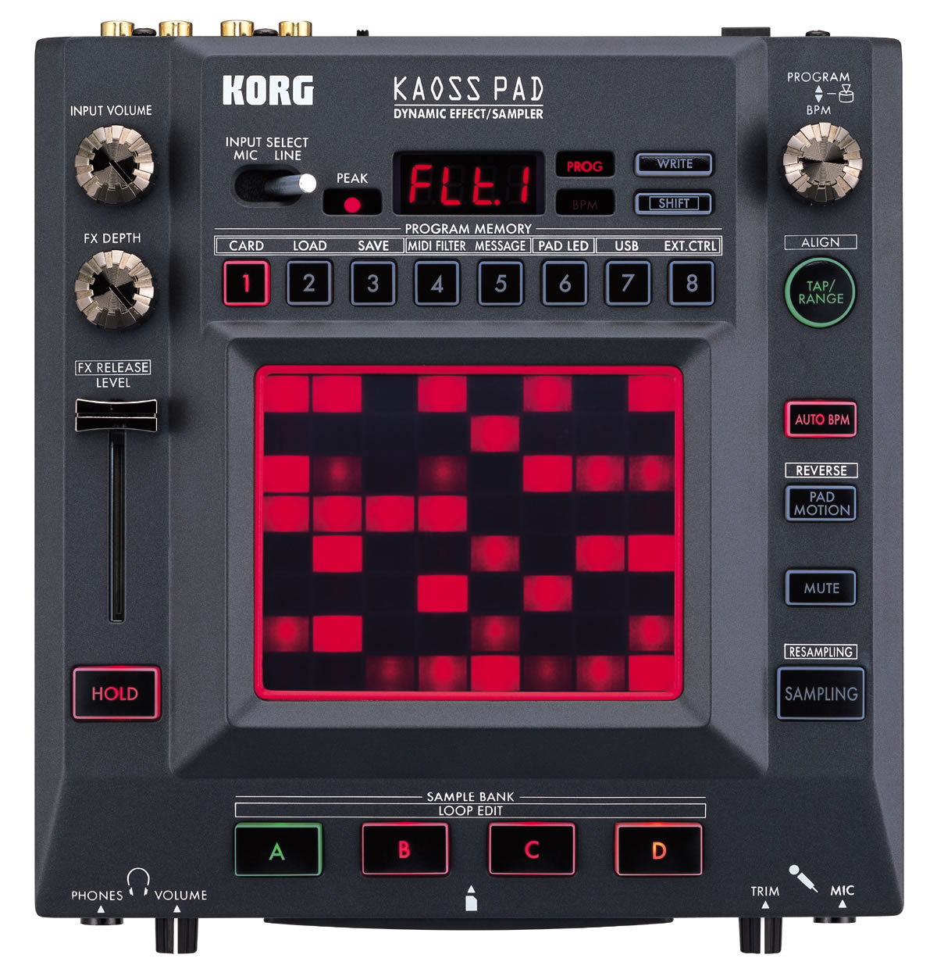
Assigned Controls
XY pad (horizontal) – Grain Position
XY pad (vertical) – Grain Length
FX Depth Dial – Smooth/Ring Mod
FX Level Slider - Channel Crossfader
Hold Button – Pan Jitter

Notes:
As the Kaoss Pad is actually running in normal functioning mode as opposed to USB or EXT. CTRL, it is possible to use the KP3's Pad motion and Reverse Pad motion as normal to create movements similar and more advanced than GranularSugar's Auto-scrub function. This works by the KP3 memorising any movements you make on the KP3's XY Pad and repeating this information back to GranularSugar (note this does not actually use the AutoScrub but works in a very similar way). This means that you can speed up and slow down, jump positions by tapping the pad and reverse the pad motion.

Appendix 1
Proposal

Concept/ Idea

Granular sampler instrument

Over the last few years I have enjoyed experimenting with granular synthesis on programs such as Absynth and Reaktor. I was made aware of granular concepts and sounds through artists such as Autechre, Aphex Twin, Venetian Snares and Apparat (http://www.youtube.com/watch?v=PVdKacGcRQs). After experimenting with granular synthesis mostly in Reaktor, I began creating sounds to use in my own music. A feature that I particularly enjoy is being able to sculpt sound using unconventional controls such as grain position, length, density, smooth and speed and then re-pitching the sound across a midi keyboard. For me this opened up an exciting new range of sound possibilities and textures as I find the process of sculpting these sounds by ear very appealing and different compared to creating sounds on a subtractive synthesiser for example.

There are many things that I like about the Reaktor instrument ‘Traveliser’ and ‘Grainstates’ but there are functions of both that I am not particularly interested in using, and that while one has the ability to do one thing, the other does not. I realised that while these programs have the ability to create many semi-random unpredictable sounds and textures, it took a lot of careful tweaking to produce the controlled musical sounds that I prefer. Also I didn’t feel that they were very useable in a live/performance situation. For these reasons I have decided to use granular synthesis as a starting point for my system. After research, I am still not aware of any programs that are dedicated to creating the sounds that I have in mind which is why I am interested in the idea of making a system that is quite unique and personal to me, that I will want to use myself in music sound creation and performance.

So what do I want my system to do?

It will need to be able to store and read pre-recorded samples/grainclouds as well as continuously reading incoming audio signals such as in the ‘Grainstates FX’ plug in.
It will need a variety of parameter controls such as grain position, grain length, smooth (grain fade in/out time) and the ability to scrub through the audio. Other useful features could include a position control which automatically scrubs through the grain cloud with controls to specify speed and amount. Another useful feature would be a ‘Hold’ or ‘Freeze’ button to catch and pause the playhead, this will provide a ‘glitchy’ effect whenever used.

It will need to be able to re-pitch the sampled sound using a midi keyboard controller. Initially I will be using a “kslider” object with an “mtof” (midi to frequency) object to change the pitch of the playback on screen but I will also need it to work with hardware midi keyboard controllers. I can use the “notein” object to assign midi controllers (see p5 for more detail on all of these objects). Ideally I would also like to have other functions assigned to buttons, dials and faders on the midi keyboard controller. Incorporating other hardware controllers such as midi pedals to control parameters and buttons for example ‘speed’ and ‘freeze’ function, would improve the usability.
Adding some random elements to the system will help to add spontaneous textures for improvised music and soundscapes. Both ‘Traveliser’ and ‘Grainstates’ use a jitter control which has been applied separately to pitch and position. I would like to create a pan jitter effect; as I’m not aware of an object that already does this, I could create my own using the “random” object. A delay effect would also be useful for emphasising the granular sound I have in mind particularly if it was synchronized with the pan jitter.

Volume Envelope for the sculpting of sounds, an ADSR volume envelope would help to increase the amount of control that the user has over the sound, making it a more playable instrument.
Max/MSP has a presentation mode which allows you to select parts of your patch such as buttons, faders and any objects that you need to use and present them to the user in a visually easy to understand way. This means that things you don’t need to see such as patch chords and unused objects can be hidden so that they do not clutter the screen and confuse the user. In presentation mode you can move, rename and resize objects around the screen without changing they’re function. The “panel” object can be used to create simple backgrounds for presentation. Panels can be sent messages to change size and colour as well as being used with a “ubutton” object to make buttons. You can also control features of panels from the inspector, use “fpic” to load your own pictures as backgrounds, buttons or cursors.

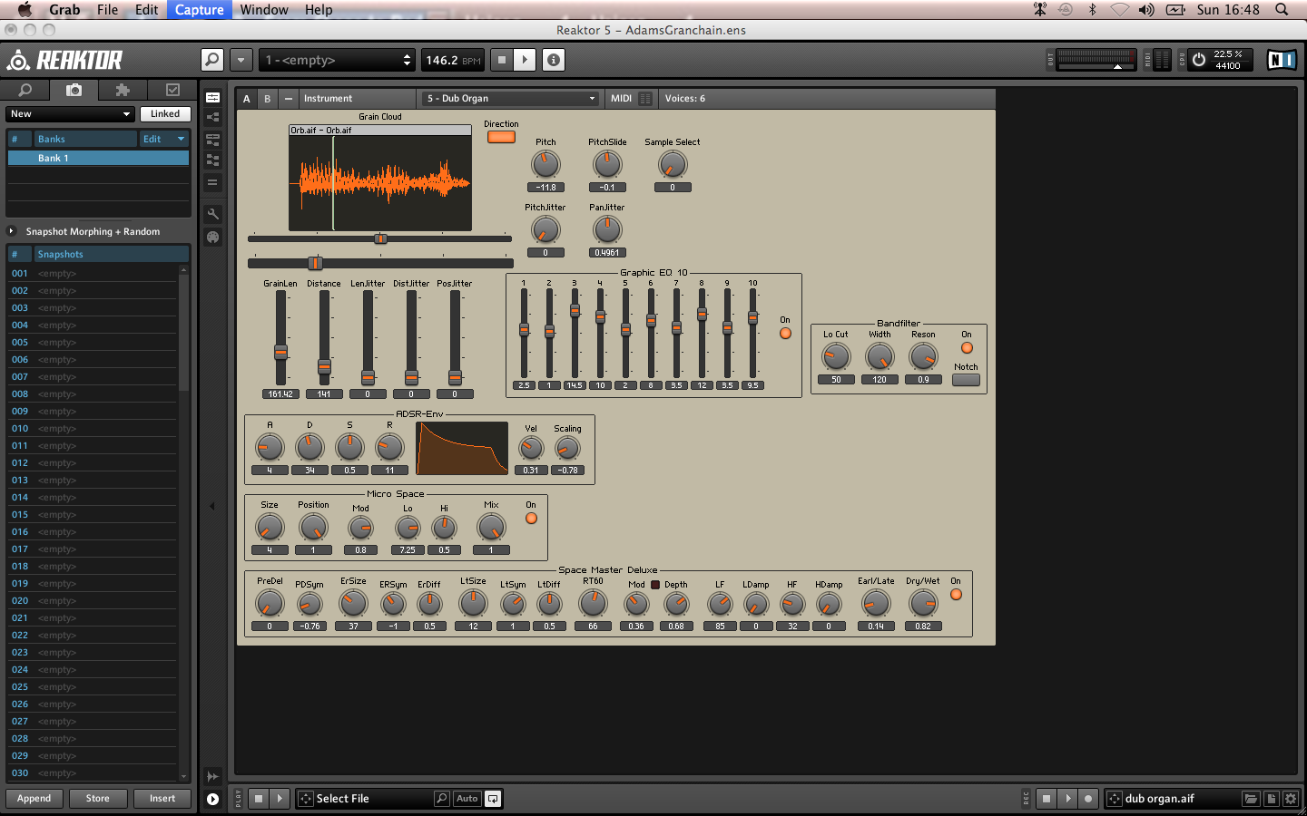
My system needs a straightforward GUI with the ability to create, store and recall presets. This could either be in the form of the “preset” object or better still a selectable list so that presets can be given names and descriptions. The interface will be divided into different coloured/bordered sections. One section will contain the controls for the loading and selection of files. Another section will be the “waveform~” section where you will have a visual selectable display of the soundwave of the sample. Another section will contain the grain modification controls such as speed, pitch and length. Another section will be the volume envelope and effects section which will contain controls for all relevant parameters such as attack, decay, sustain, release, delay time, amount, feedback. XY pads have been used by Traveliser and Grainstates to control various parameters such as speed, length, position and pitch and they work very well so I will probably experiment with these. If they make my system easier for the user then I will use them in my final design.

The system should be usable to almost anyone interested in experimenting with granular synthesis. Because it can hold live audio and use pre-recorded samples it has the possibilities to be used by DJ’s, producers and performers in a variety of ways. The use of midi pedals would greatly add to the flow of the system as a performance tool making it part of an experimental live setup for solo artist, band or DJ.

Prototype

For my prototype I want to be able to load samples into a buffer as well as record live audio into a buffer, I then want to be able to re-pitch it on a midi keyboard. The prototype will feature buttons associated to the “waveform~” object to select cursor as well as instructions for keyboard commands. The prototype should have a simple delay effect. It should also have a pan feature possibly using the “pan2” object. The prototype should have a volume envelope as well as a smooth function to counter clicks between grains.

The GUI should have a visual waveform such as the “waveform” object that selections can be made to using the mouse and keyboard functions. These selections will be for selection length and position. It will also have buttons to select different cursors such as scrub, draw, move from a sub-patch. It will also contain message buttons to replace the file, crop and undo and well as level meters and faders and control for the smoothing function.

How will I further my project? How could it progress in the future?

As the main focus of my project is to make a playable granular sampler instrument, I would like to develop it further by adding granular inspired effects such as a glitch/stutter, delay. Other effects that I think would be well suited could be a resonator. I would like to develop more control over the sound by including a filter. Ultimately it could be made into a plug in instrument for ease of use with a sequencer.

Timeline
December – December will be spent making small patches that perform various functions that I have identified as being needed. This will include things such as keyboard triggers, a few different types of simple envelopes for grain smoothing. I will aim to assemble all of the things needed to create a basic version of my prototype.
1st week – Begin by making some small patches. By the end of the week I should be able to load a sample into a buffer, view it as a wave form, loop, playback and select chucks of audio/grains as well as a crop and undo function.
2nd week – By the end of the week I should be able to record live into a buffer. I will also build a simple envelope to smooth off clicks (see p5 for more information).
3rd week – Include an on screen midi keyboard and by the end of the week have a midi controller working.
4th week – Try out associated externals/abstractions and evaluate and compare to groove/play objects (see p6 for a list and explanation of these externals/abstractions.
January -
1st week – Make a volume envelope possibly by using the adsr~ object.
2nd week – Consider and add two simple effects; delay and pan.
3rd week – Consolidate work and make final changes to prototype
4th week – Design GUI for my system using presentation mode
31st Jan – Prototype Deadline
February – throughout February I will be making improvements based on the response to my prototype as well as further developing, improving and expanding on my initial ideas further.
1st week – Look at using the global transport and how this might help me to have the playhead automatically scrub through the sample selection.
2nd week – Work on the sample loading and storing function. Try to develop a more sophisticated system that lets you load and select multiple samples.
3rd week – Develop stutter/glitch effect.
4th week – Consolidate work in preparation of March
March – The state of my system by March will determine what needs to be done. In general I will look to push my system further, possibly by developing new elements such as effects, polyphony, other hardware integration, randomisation, Ableton/Max for live or expanding on initial ideas such as more sophisticated delay and panning.
1st week – Hardware controller usability; assign various parameters to midi hardware controller and consider what other controller options are possible.
2nd week – Get my system working with Ableton/Max for live
3rd week – Test and evaluate system
4th week – Final improvements based on testing and evaluation
April – will be used primarily for final improvements to the system as well as for the creation of the demonstration track and written project documentation.
1st week – Finish design of system
2nd week – Work on GUI, by the end of the week all improvements to GUI should be finished.
3rd week – Make demonstration track
4th week – Work on the written documentation. By the end of this week any problems to do with my system should be resolved; no changes should be made to the system after this unless a new problem is found. Same goes for the GUI, demonstration track and written documentation.
May – by May I should be ready to consolidate by project in time for the final deadline.
1st May – Finish consolidating project
9th May – Final Deadline

Considerations based on my research and list of useful objects
A problem commonly associated with granular synthesis is clicking at the beginning/end of grains. However in varying amounts this can be a desired sound of granular synthesis so I do not want to simply eliminate it completely. Therefore I want to include a ‘Smoothing’ control so that you can set the amount of smoothing between each grain. This is often achieved by using an envelope (Attack/Decay) such as in ‘Traveliser’. I have discovered a few different ways of doing this in Max/MSP and I’m sure there are many more that I am yet to realise.

To develop this as a live performance tool, it would benefit from being compatible with a sequencer such as Ableton live. This will be possible through using ReWire or Max for Live. “You can use Max as a ReWire client and route audio from Max into another application (such as Ableton Live...) using ad_rewire, a special audio driver” (http://www.cycling74.com/docs/max5/vignettes/core/rewire.html). The ReWire driver can be turned on by selecting ad_rewire from the DSP status menu. There are three associated objects; “hostcontrol~”, “hostphasor~” and “hostsync~” used in Max to help control synchronisation and transport messages such as start, stop and tempo. Using Max for live would be the easiest method as it lets you seamlessly use Max inside Ableton, but I will probably use ReWire until I get Max for Live.

Using a cycle~ object – if driving the cycle object by phase alone (e.g. phasor~) and manipulating the output (decreasing range) you can create a simple amplitude envelope.
trapezoid~ object may help me with making the smoothing function
adsr~ this object can be used to make a volume envelope
rslider can be used to select different ranges and move through them so this could be used for selecting parts of the sample and scrubbing through grains.
waveform~ is an object that will allow me to view and edit the contents of a buffer. It is used in a similar way to the rslider.
preset object stores presets which will help make the instrument more playable
groove~ and play~ these objects allow me to reference, communicate and loop with the buffer
phasor~, record~, ezadc~
buffer~ object will be used for loading and storing samples and capturing live audio
pan2 object is a stereo panner that I might use
kslider I can use the “kslider” to re-pitch my samples by placing an “mtof” (midi to frequency) object between it and the groove object
scale object will allow me to scale ranges
hostcontrol~, hostphasor~ and hostsync~ objects communicate with ReWire to give transport and synchronisation control.
Appendix 2
Prototype
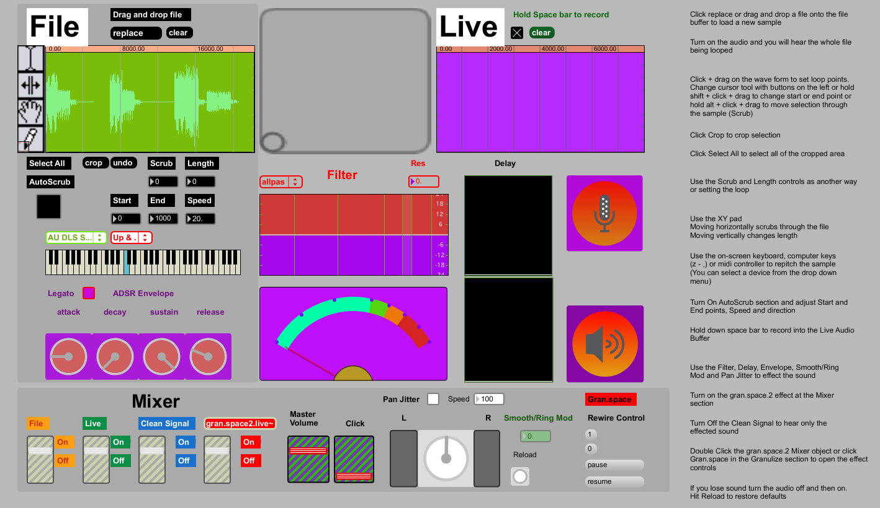
Quick start instructions are provided to the right of the GUI for the prototype

Prototype Specifications
- File Buffer – allows you to load an audio file from disk
- Live Buffer – allows you to record 10 seconds of live audio, which you can continuously overdub
- XY pad lets you Select, Crop and Scrub (alternatively use cursor select buttons, click and drag on the visual waveform boxes or buttons)
- Auto-scrub feature – set Length, Speed, Start/End positions and direction and let auto-scrub free up your hands
- Mixer – features volume faders and On and Off buttons for the File, Live, Clean and Gran.space2 channels. Also master volume and click volume
- ADSR Envelope – gives you control over the attack, decay, sustain and release times
- Filter – features adjustable Highpass, Lowpass, Bandpass, Resonant, Bandstop and Allpass presets
- Delay – lets you independently set up to four delay times and volumes
- Smooth/Ring Mod – a tremolo/ring modulation effect
- Pan Jitter – control the speed at which the signal is panned to a random position
- External Granular 'gran.space2' effect adds even more extreme granular sounds
- Midi Controller/Keyboard compatible (alternatively use the on-screen keyboard or computer keys “z to ,”) to re-pitch and re-trigger sample
- Rewire Control – lets you easily route audio into Logic, Ableton and other Rewire compatible software
- Wiimote and Kaoss Pad compatible – use the Nintendo Wiimote and Korg Kaoss Pad to control parameters in new and exciting ways

Prototype Quick-start guide
- Upon opening you will be prompted to select an audio files
- Click replace, or drag and drop a file onto the file buffer to load a new sample
- Turn on the audio and you will hear the whole file being looped
- Click + drag on the wave form to set loop points. Change cursor tool with buttons on the left or hold shift + click + drag to change start or end point or hold alt + click + drag to move selection through the sample (Scrub)
- Click Crop to crop selection
- Click Select All to select all of the cropped area
- Use the Scrub and Length controls as another way or setting the loop
- Use the XY pad (Moving horizontally scrubs through the file, moving vertically changes length)
- Use the on-screen keyboard, computer keys (z - ,) or midi controller to repitch the sample (You can select a device from the drop down menu)
- Turn On AutoScrub section and adjust Start and End points, Speed and direction
- Hold down space bar to record into the Live Audio Buffer
- Use the Filter, Delay, Envelope, Smooth/Ring Mod and Pan Jitter to effect the sound
- Turn on the gran.space.2 effect at the Mixer section
- Turn Off the Clean Signal to hear only the effected sound
- Double Click the gran.space.2 Mixer object or click Gran.space in the Granulize section to open the effect controls
- If you lose sound turn the audio off and then on. Hit Reload to restore defaults

Using the Granular Sugar Prototype
The Granular Sugar prototype allows you to drag and drop an audio file onto the wave form display (alternatively click replace to open the browser window). The display and associated parameters will all be adjusted automatically and resized to fit the length of the new file. With the file now loaded into the waveform object, you can select regions of the displayed wave and continue to loop it. By holding the shift key and clicking, you can change the start and end points separately. By holding the alt key and clicking and dragging, you can scrub the selected loop/region through the file. You can also use the scrub and length controls in exactly the same way to control the start point and length. With a region selected you can crop it many times and select smaller grains of sound. The XY pad also works with these controls.
By selecting the auto-scrub toggle, the region will automatically scrub through the file. In the autoscrub section you can select start and end points, select from the menu whether to move forwards, backwards or forwards then backwards through the file. You can also change the speed at which this happens.
As well as a file buffer, there is a live audio buffer which holds 10 seconds of audio. You can record by holding down the space bar. Playback will begin to loop and you can then overdub continuously by holding space again. It also has a metronome which can be heard by turning up the volume fader. The live signal joins the file signal at the filter, so is processed in exactly the same way as the file, however at this stage you cannot re-pitch or re-trigger.
My patch also contains an external granular effect called gran.space2~ from Nathan Woleks granular toolkit. This effect processes signal in a variety of ways. It can be opened by double clicking on its heading in the mixer. It has controls for window shape, grain offset, buffer size, grain length, pitch multiplier and grain stream.
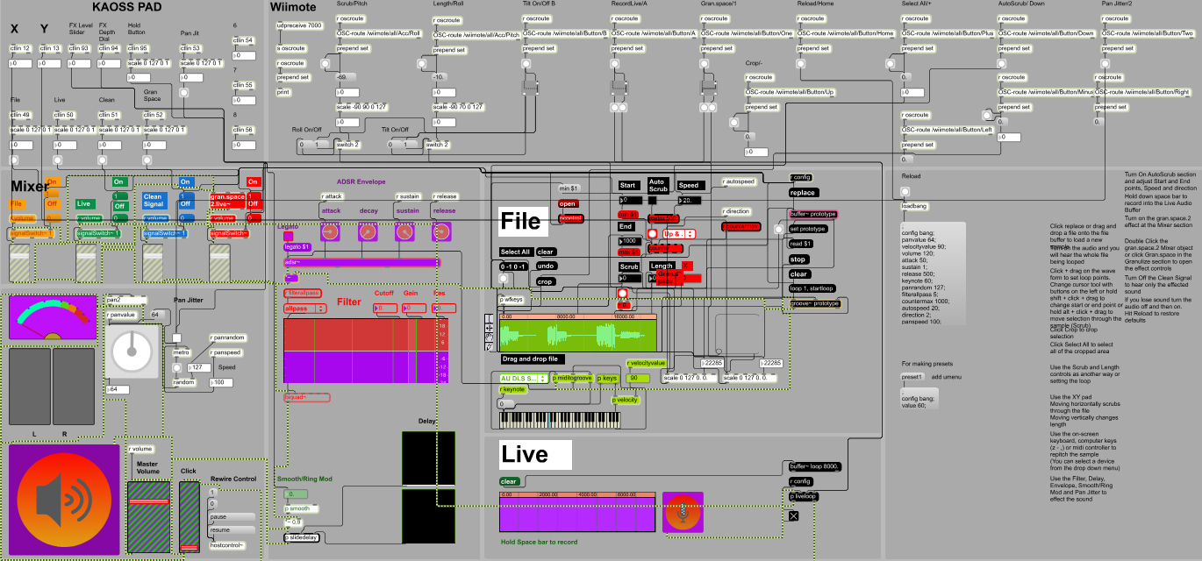

Future Improvements
- Live Buffer – currently the live buffer cannot be re-pitched or re-triggered, selected or cropped or any of the other functions associated with the File Buffer such as Auto-scrub, or envelope. For my final product the Live buffer will be capable of doing everything that the File buffer can do.
- Mixer/switch section – Currently the live audio signal and file signal are being combined at the filter section, then the 'clean signal' and gran.space2 external are being added on top instead of mixed together proportionately (the delay effect also suffers from this same problem, although it does not need its own channel in the mixer). This means that the volume levels raise and fall dramatically as you change parameters and also makes the mixer overly complicated to use as the 'clean signal' channel is only there as a quick way to get around the problem. I need to create a better mixer that balances volumes and allows you to route and switch signals efficiently. This means that you will instead be left with a more manageable three signals; File, Live and FX.
- Envelope – the envelope is not currently functioning in a very conventional way. There seems to be a problem with the Sustain and Release controls particularly. The Sustain functions as a volume control and the Release does not work because the sounds are indefinite. Also even at full, the attack does not give you a long attack time. I suspect this has something to do with the min and max numbers that the envelope is set to. Fixing this will give the user the ability to have far greater control over the envelope of the sound they are producing.
- Delay – The delay effect is overly complicated to use and does not have a feedback control which have been useful. The design of its GUI also is not particularly sensible either so I will be replacing this in my final product with a design that utilises feedback controls and dials.
- Polyphony – the prototype allows you to use the gran.space2~ external to create a second pitch but I would like to develop full polyphony of at least eight pitches within my instrument. This will mean you can play large chords as opposed to only one note.
- The Auto-scrub Counter Speed behaves erratically around 0-2, this needs to be limited or scaled and inverted so that the user has smooth control over the parameter.
- The Smooth/Ring Mod needs to be limited because if set between 0-1, and left you will lose sound for a long amount of time and the user may not be aware of why this is. It is not really necessary to have it running this slow so should be limited to avoid confusion!
- To extend possibilities it might be useful to be able to record the signal being output into another buffer so that you could sample and re-sample multiple times allowing you to create and store complex sounds.
Bibliography and Research sources

- Roads, C. (2004) ‘Microsound’. This book contains explanations of the fundamental concepts involved in granular synthesis, the history of microsound from ancient philosophies right through to modern digital granular synthesis techniques and even considers the aesthetics of microsound composition.
- http://www.soundonsound.com/sos/dec05/articles/granularworkshop.htm – Great article about granular synthesis.
- Max/MSP abstractions and externals – From my research I have found particular abstractions/externals commonly used and built specifically for granular synthesis in Max.
- mdeGranular~ was made by Michael Edwards and can be found at http://www.michael-edwards.org/software/mdegranular/mdegranular.html/ “A Max/MSP external object for multi-channel, multi-voice, multi-transposition granular synthesis”.
- Granular Toolkit v1.49 by Nathan Wolek is a set of externals and abstractions which utilise several granular synthesis concepts such as pitch shifting, spatializing, clouds, chord production and looping. According to Nathan Wolek, the reason he made this toolkit was because Max/MSP does not include sufficient externals to meet the efficiency and flexibility needs for creating such effects. http://www.lowkeydigitalstudio.com/2007/03/granular-toolkit-v1-49/
- GrainTools by Marcel Wierckx is a set of abstractions for performing various granular synthesis tricks. http://www.lownorth.nl/software/downloads/graintools.zip
- Various Reaktor instruments involving granular synthesis such as ‘Grainstates’ and ‘Traveliser’ as well as user made ensembles. This helped me to see different methods of making granular synthesisers in Reaktor and helped me decide on what parameters and elements were most important to me when building my own which is transferrable to Max/MSP.
- Youtube channel ‘Joelisrich’ http://www.youtube.com/user/joelisrich . This youtube channel contains some simple videos that helped me to get started.
- Youtube tutorials and Max/MSP tutorials and help files
http://www.youtube.com/watch?v=Ltyo_KB8J94 (Groove object)
http://www.youtube.com/watch?v=Z-1nRI4eaKc (Granular)
http://www.youtube.com/watch?v=LoA0a-zFC8c (Delay)
- Information and advice for using ReWire in Max/MSP; http://www.cycling74.com/docs/max5/vignettes/core/rewire.html
- KP3 Editor software
- KP3 Owners Manual
- http://www.davebv.com – Music Controller Program (for Wiimote)
- http://cycling74.com/2011/05/05/polyphonic-synthesizer-video-tutorial/#more-10424 – tutorial on turning patches polyphonic
- http://socialsounddesign.com/questions/20/max-msp-and-computer-keyboard-stuff – help with using keyboard keys to trigger samples
- http://www.korgforums.com/forum/phpBB2/viewtopic.php?p=366414&sid=862925f52f3739e2e9277cdcccdfea71 – discussion of Kaoss Pad as midi controller

